Game Meat / Viande de gibier
Kangaroo / Kangourou
Salami - Sliced

Ingredients: Domestic kangaroo, Pork, Beef, Sea salt, Sugar (maple syrup), Cultured celery powder, Pepper, Garlic, Starter culture, Natural wood smoke.
Ingredients: Kangourou domestique, Porc, Bœuf, Sel de mer, Sucre (sirop d’erable), Poudre de céleri de culture, Poivre, Ail, Culture starter, Fumée de bois naturel.

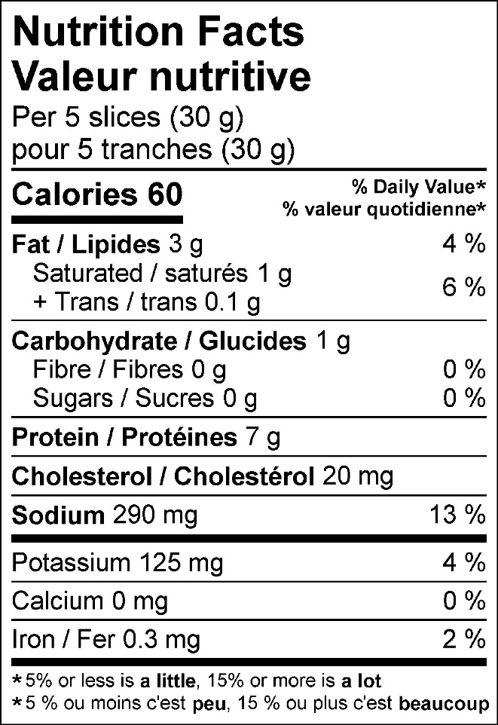

125 g pack
